Sunday 7th September 2025
Lesson 18

Class room - Worksheet walkthrough 2
Question 1 2
Question 2: 3
Question 3 4
Question 4 4
Question 5 5
Question 6 5
Question 7 6
Question 8 6
Question 9 7
Question 10 8
Question 11 9
Question 12 9
Question 13 10
Question 14 10
Question 15 11
Question 16 11
Question 17 12
Question 18 12
Question 19 12
Question 20 13
Question 21 14
Question 22 14
Question 23 16
Question 24 18
Question 25 18
Question 26 19
Question 27 20
Question 28 21
Question 29 22
Question 29 working out 22
Question 30 22
Question 31 22
Question 32 23
Question 33 23
Question 34 23
Question 35 24
Question 36 24
Question 37 24
Question 38 24
Question 39 25
Question 40 25
Classroom theory 25

Class room - Worksheet walkthrough
5357 - 003 Electrical Scientific Principles and Technologies /
2365-602 Principles of Electrical Science

Question 1

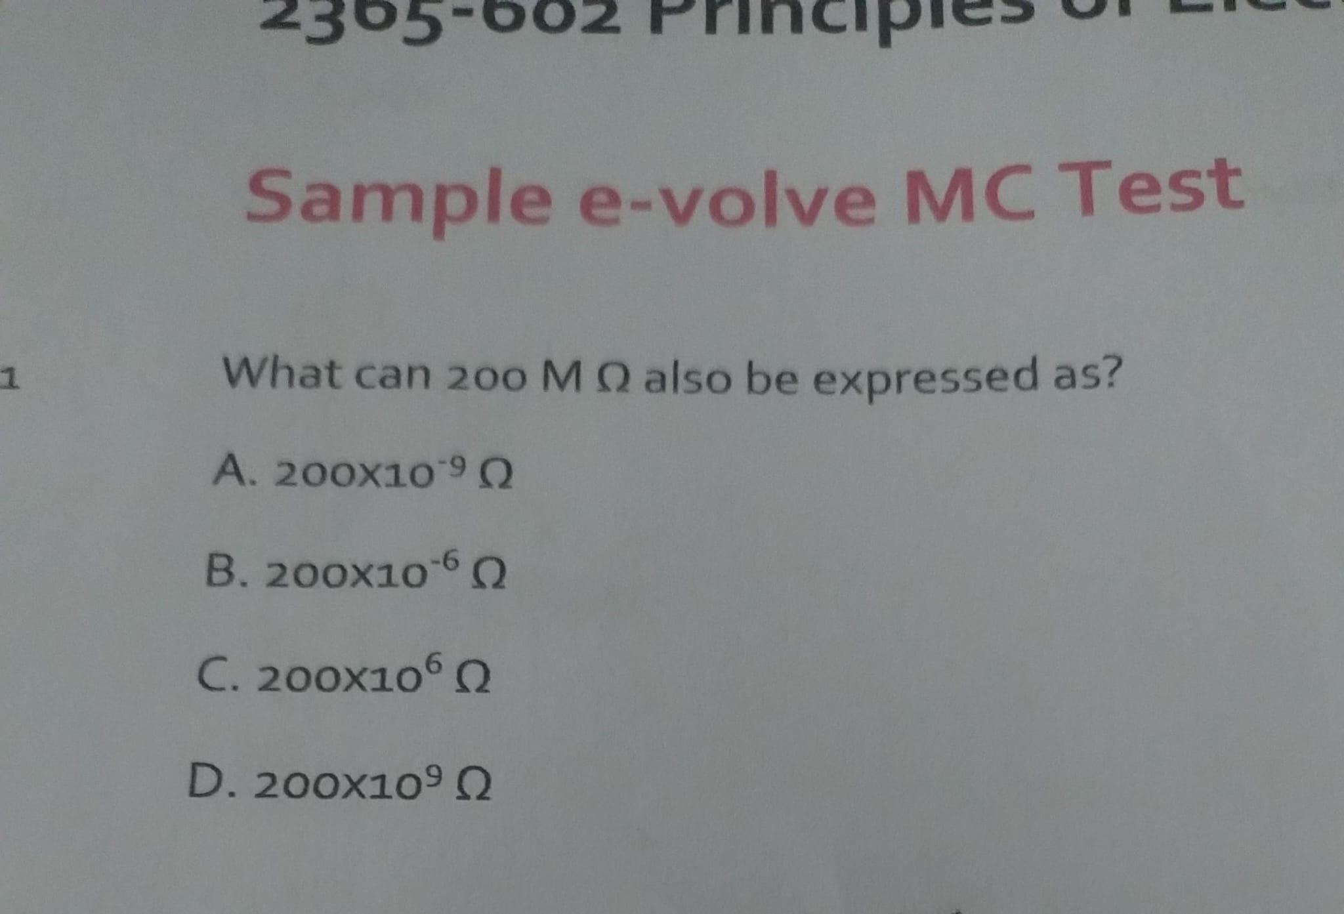

Question 2:
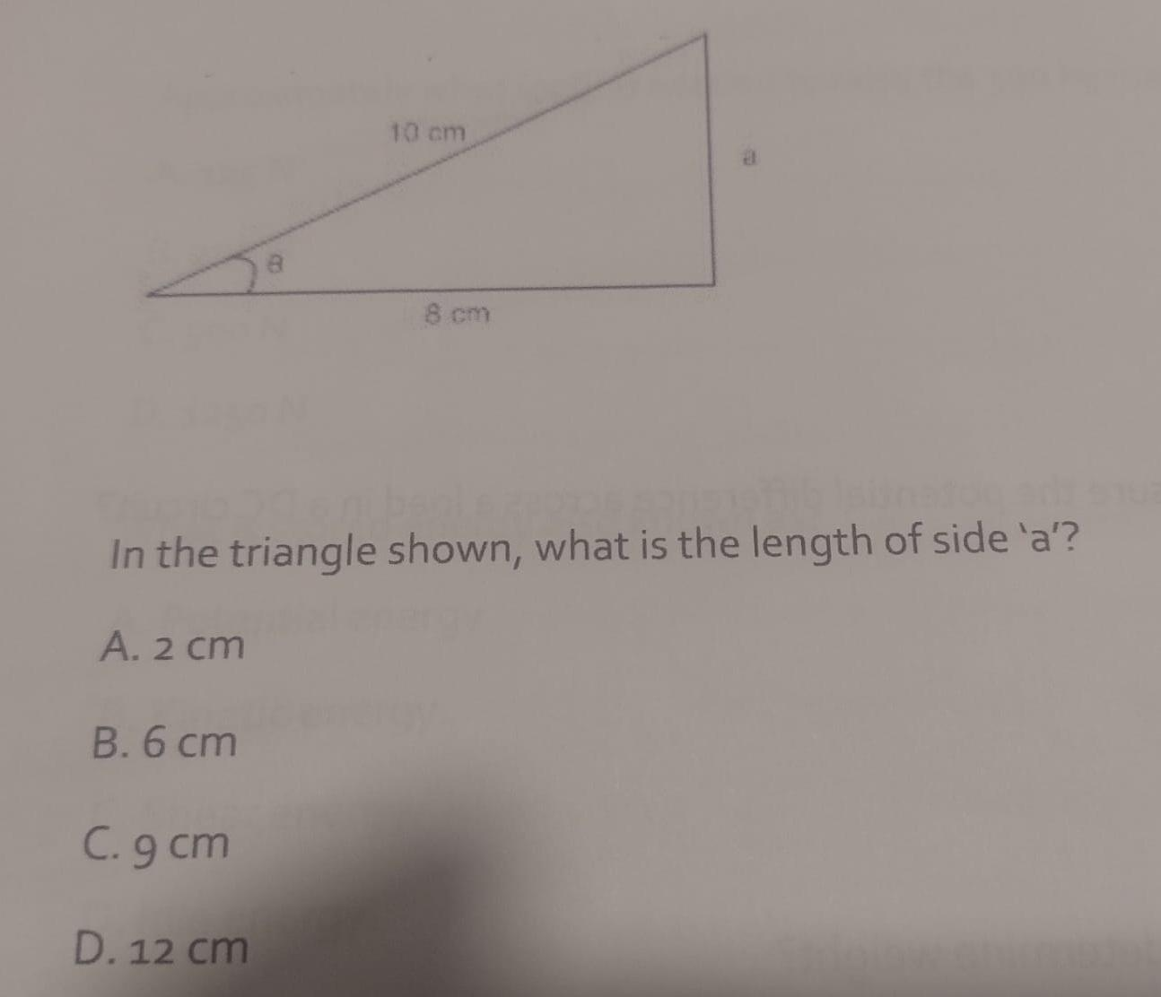

Question 2 working out:

Foundation:

The formula a² + b² = c² is known as the Pythagorean theorem, which states that in a right-angled triangle, the square of the hypotenuse (the longest side) is equal to the sum of the squares of the other two sides (the legs).

This means that if you square the lengths of the two shorter sides (a and b) and add them together, you get the same value as squaring the length of the longest side (c).

Original source: google

Answer is 6 cm

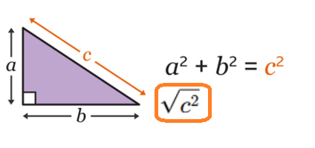

C = The hypotenuse which is the longest side of the triangle.

a = 8 cm | c = 10 cm | b = ?

- Following, the rule we know that performing the addition:

- a² + b² = c²
- a² + b² equates to c²

The question already gave us the value for c to be 10. So c² = 100.

Therefore, a² + b² has to equal 100.

We already have a value for a to be 8 cm. So a = 8 cm.

8² = 64. Which is 36 away from 100. The square root of 36 is 6. Therefore the answer for b = 6 cm.

Question 3

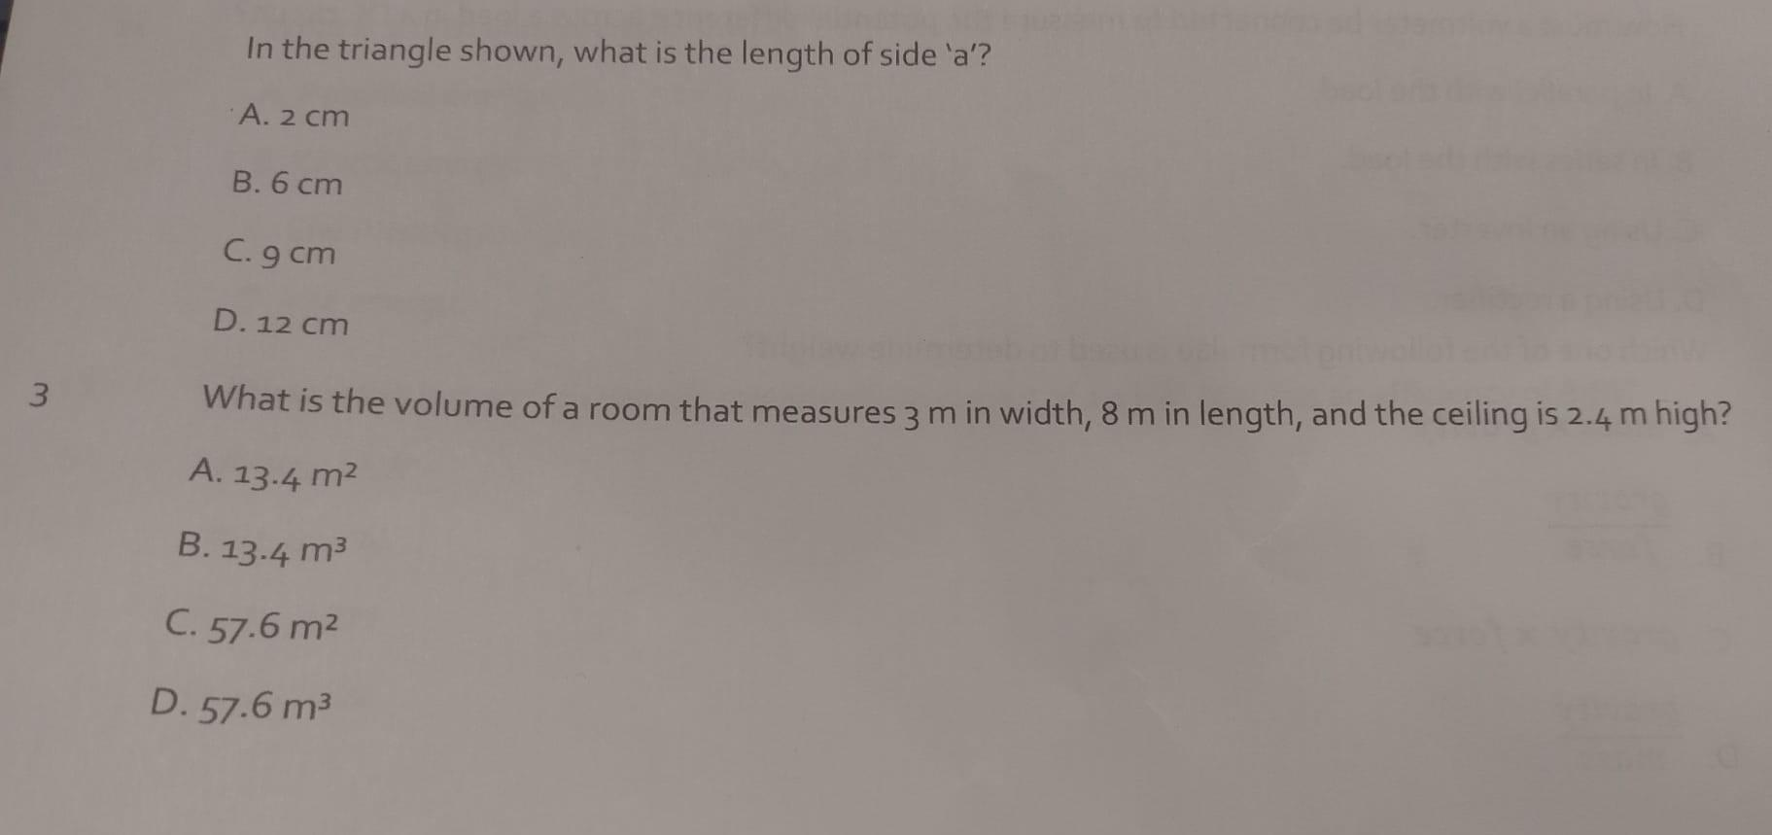

Question 3 working out

The answer is C.

Perform the multiplication 3 m x 8 m x 2.4 m = 57.6m²

Question 4

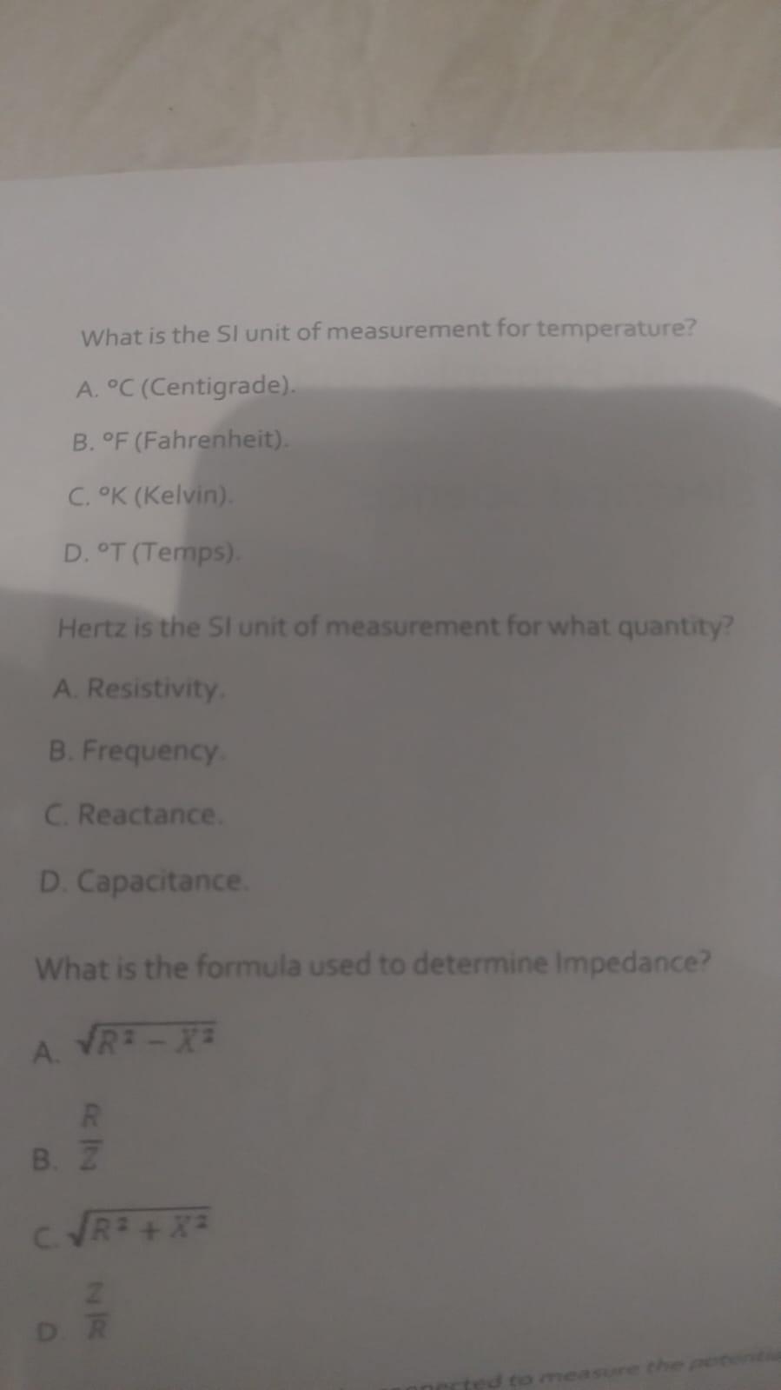

Question 4 working out

The answer is Kelvin

Question 5

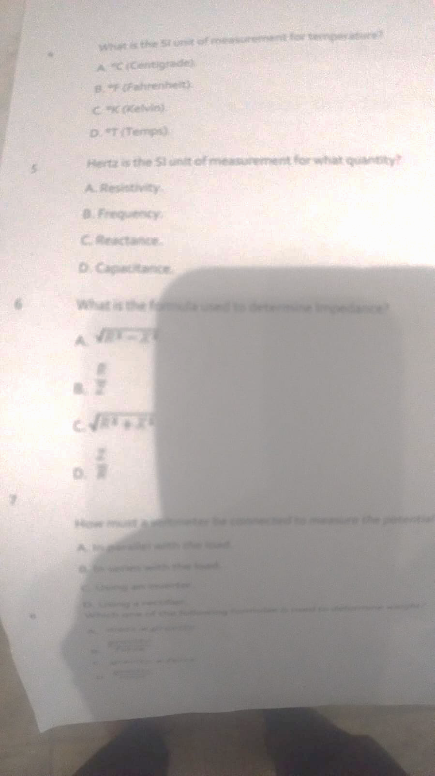

Question 5 working out

The answer is B frequency

Question 6

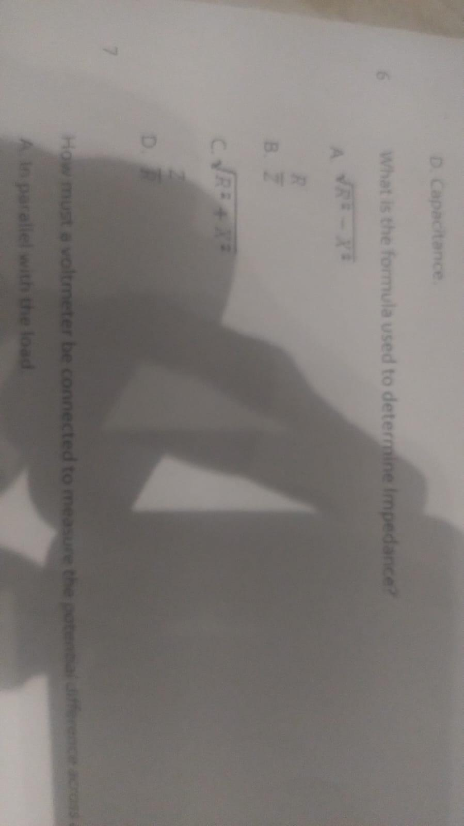

Question 6 working out

The answer is C

Question 7

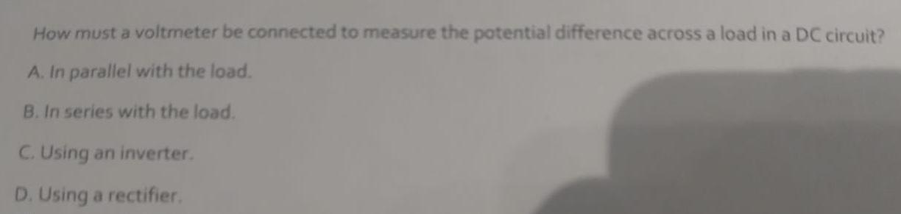

Question 7 working out

The answer is A

Question 8

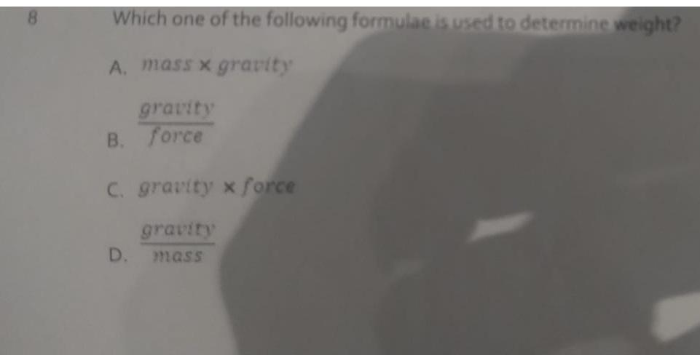

Question 8 working out

The answer is A) weight = mass x gravity

Question 9



Question 9 working out

The answer is B) A lever

Question 10

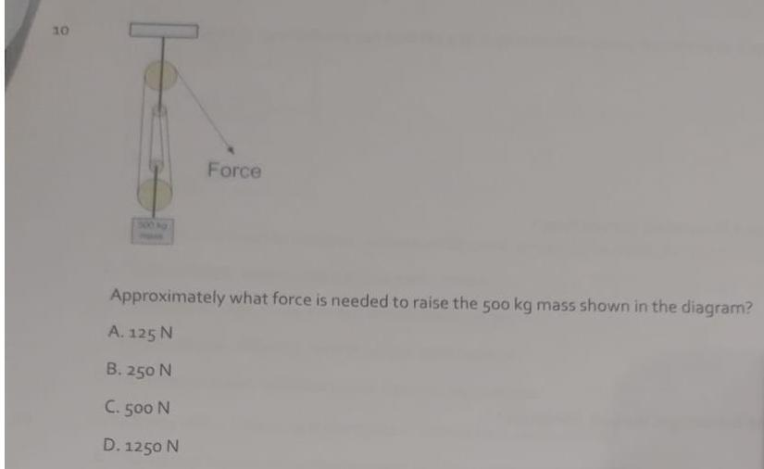

Question 10 working out

There are 4 pulleys (represented by four circles)

The weight is 500 kg.

The formula is: Force = Mass x gravity

4905 = 500 kg x 9.81

Question 11
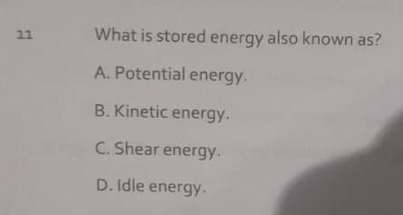

Question 11 working out

The answer is A) Potential energy

Question 12

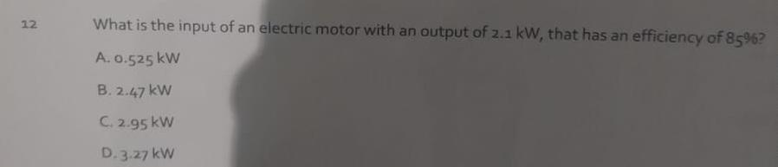

Question 12 working out

The answer is B => 2.1 / 0.85 = 2.47

Question 13

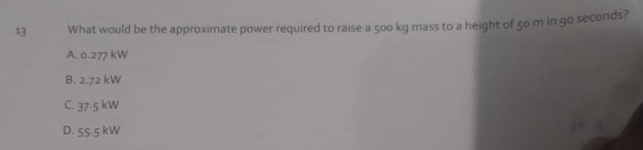

Question 13 working out

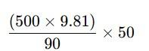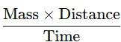

Question 14 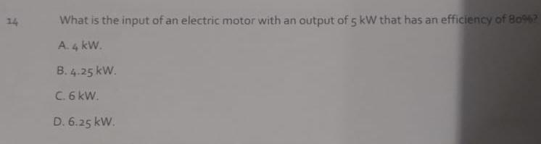
Question 14 working out

5 / 0.80 = 6.25 kW

Question 15

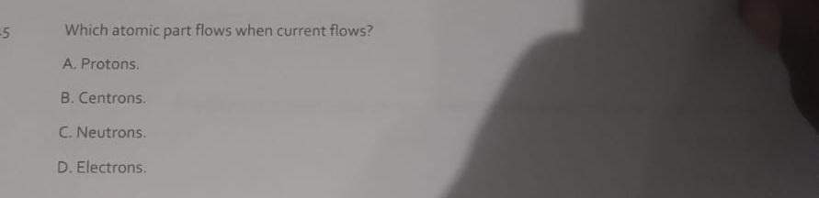
Question 15 working out

The answer is A) Protons

Question 16

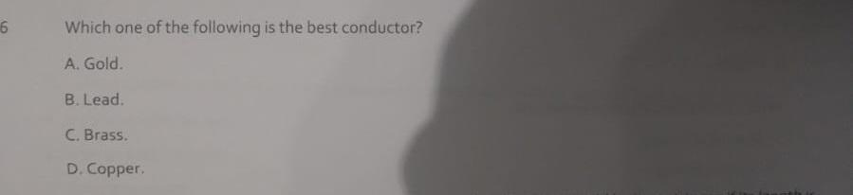

Question 16 working out

The correct answer is D) Copper.

Gold is also a conductor of electricity.

Question 17

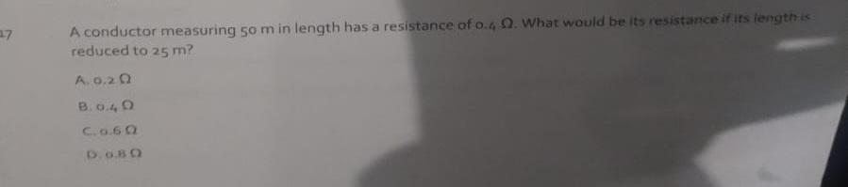
The correct answer is A) 0.2 ohms.

When you half the distance you half the resistance.

Question 18
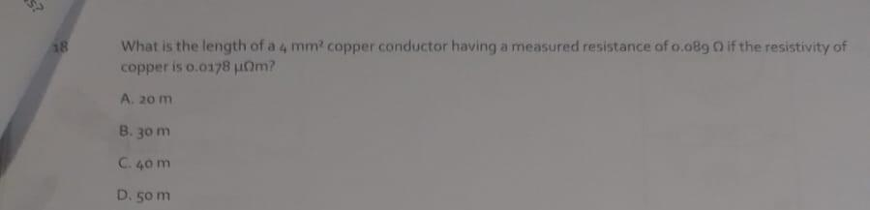

Question 18 working out

Question 19

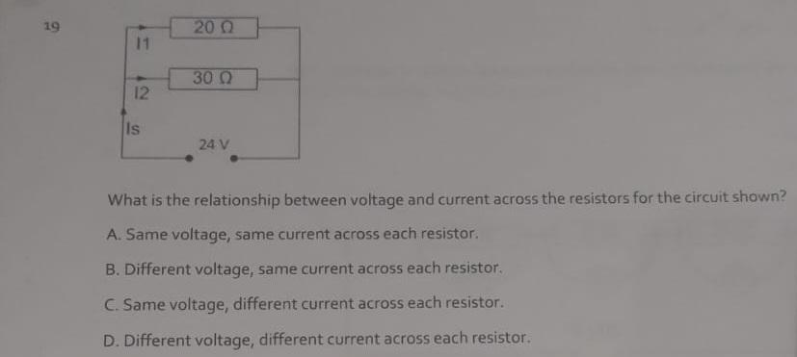

Question 19 working out

The circuit shown is a Parallel circuit.

The answer is D.

In a parallel circuit; the voltage is constant, the current differentiates.
In a series circuit; the current is the same and the voltage changes based on the resistors.

Question 20

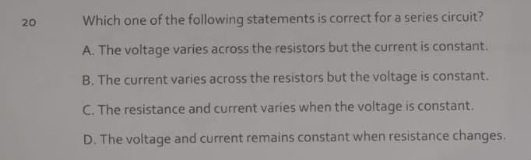

Question 20 working out

The answer is A) The voltage varies across the resistors but the current is constant.

Question 21
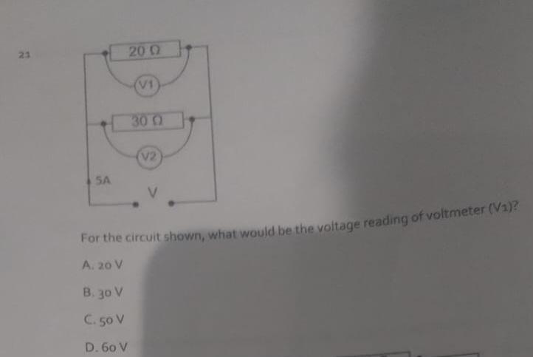

Question 21 working out

VIR formula triangle.

V = I x R.

Therefore, 5 A (the current is constant in a series) x 20 ohms of resistance -

Question 22

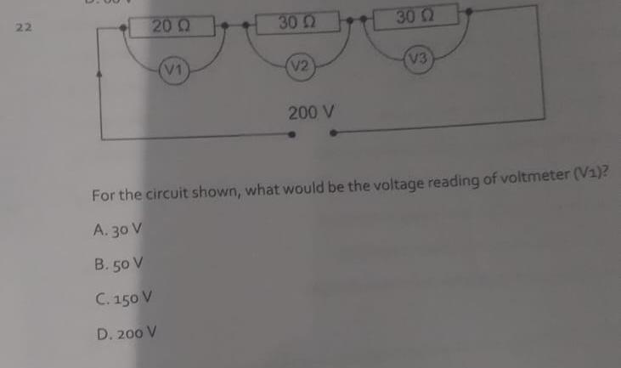

Question 22 working out

The answer is B) 50 V.

This circuit is a series circuit.
In a series circuit the current is constant and the voltage changes around the resistors.

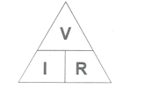

The total voltage is given as 200 V.
We can calculate the total resistance as (20Ω + 30Ω + 30Ω) = 80Ω.
We can then calculate the total current for the series circuit = 2.5 A.
I = V / R => 2.5 A = 200 V / 80Ω

The current of 2.5 A is constant in a series circuit.

Then we do Ohms law around each resistor.

V1 = 2.5 A x 20Ω => 50 V
V2 = 2.5 A x 30Ω = > 75 V
V3 = 2.5 A x 30Ω = > 75 V

Question 23

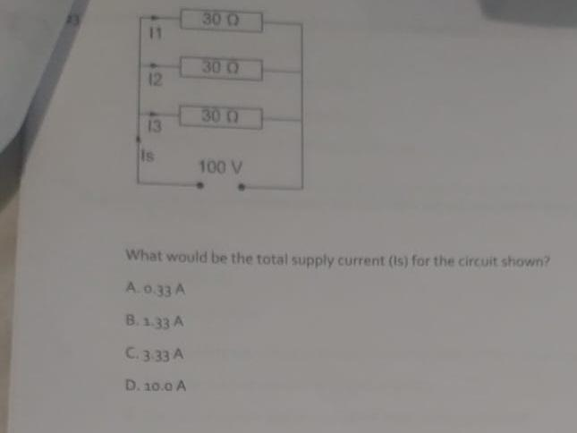

Question 23 working out

V_{T} = 100 V
I_{T} = ?
R_{T} = 90Ω (we do not add up the resistor/resistance values as we would do in a series circuit)
1/rt = 1/30 + 1/30 + 1/30
0.1 = 0.0333 + 0.0333 + 0.0333
0.1 => 10Ω (multiply by 100)

I_{T} = 100 V / 10Ω
I_{T} = 10 amps

In a parallel circuit; the voltage is constant and the current differentiates.

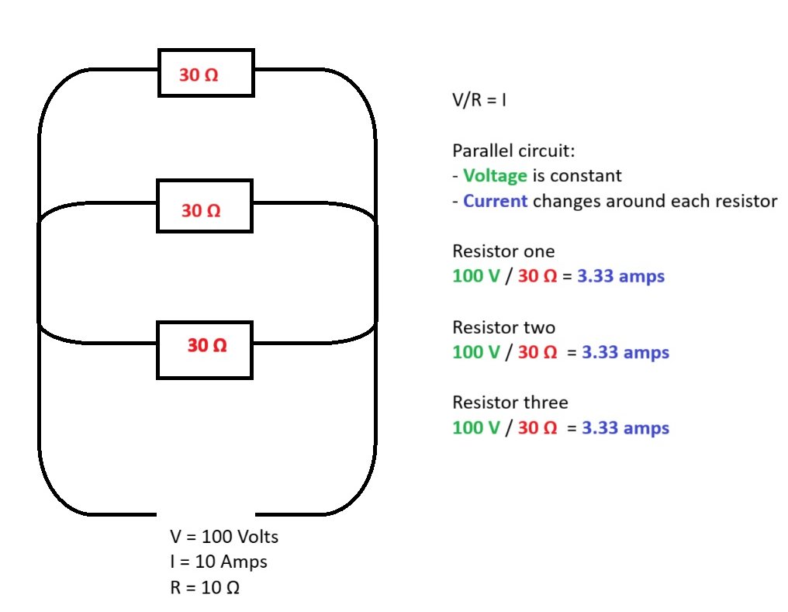

Question 24
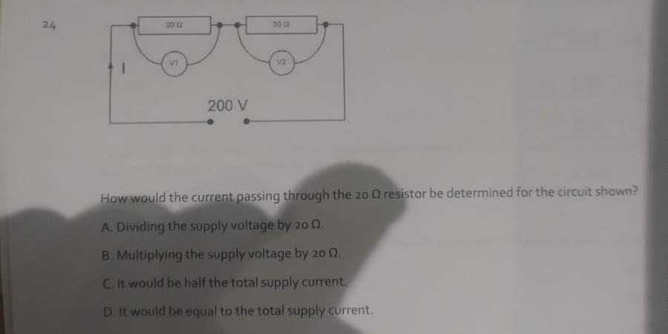

Question 24 working out

The answers is D

The current is constant in a series circuit and the voltage changes around the resistors.
I = Voltage / Resistance.
200V / 50 ohms Ω = 40 amps

Question 25

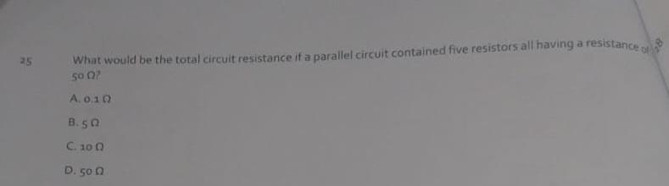

Question 25 working out

The answer is C) 10 Ω

The questions: “What would be the total circuit resistance if a parallel circuit contained five resistors all having a 50Ω?”

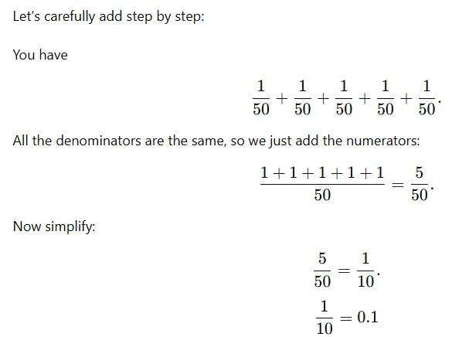

Question 26
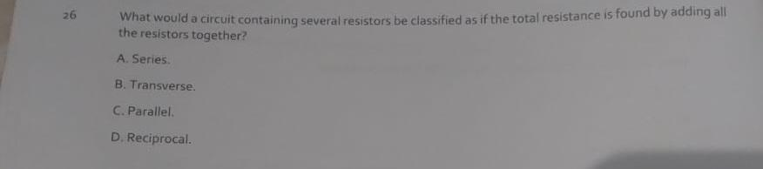
Question 26 working out

The answer is A) Series.

In a series circuit you can calculate the total resistance by adding all of the individual resistors together.

Question 27

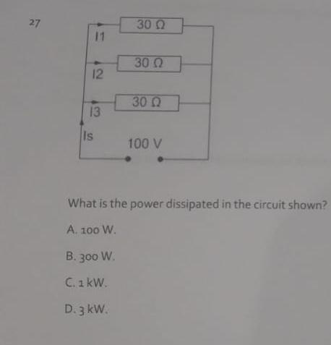

Question 27 working out

In a parallel circuit the voltage is constant. The current differentiates.

Whenever power is mentioned the formula to use is PIV. P = I x V.

The question provides us with the voltage and the information to calculate the total resistance. However, we need to use the VIR formula triangle first to get the I (current) in order to calculate the power.

V = 100V
I = ?
R =>
1/30 + 1/30 + 1/30 = 3/30.
3/30 simplified = 1/10 => 0.1.
0.1 x 100 = 10Ω.

100V / 10Ω = 10 amps

V = 100V
I = 10 amps
R = 10Ω

Now we have the current and the voltage so we can deduce the power. Using the power formula triangle.

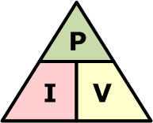

Power = Current x Voltage
1kW = 10 amps x 100V

Question 28
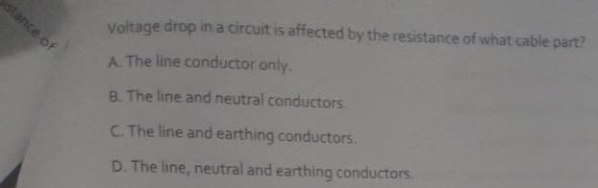
Question 28 working out

The answer is B

Question 29
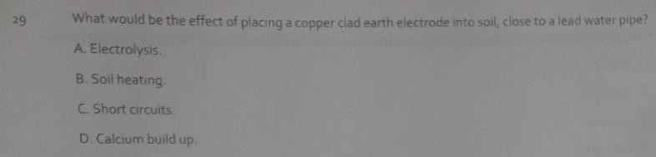

Question 29 working out
The answer is A

Question 30
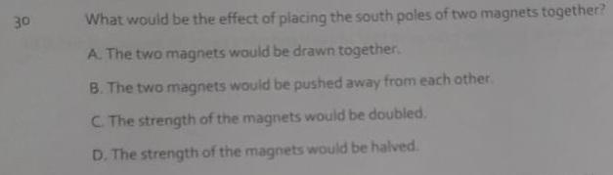
The answer is B

Question 31
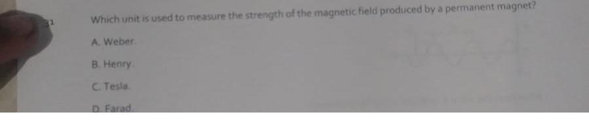
Question 31 working out
The answer is B

Question 32
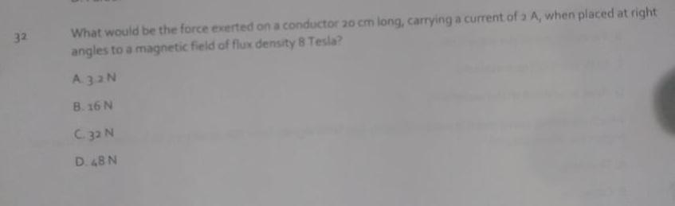

Question 32 working out

Question 33
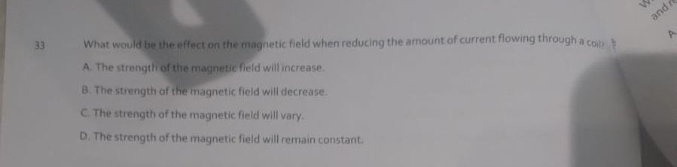

Question 34
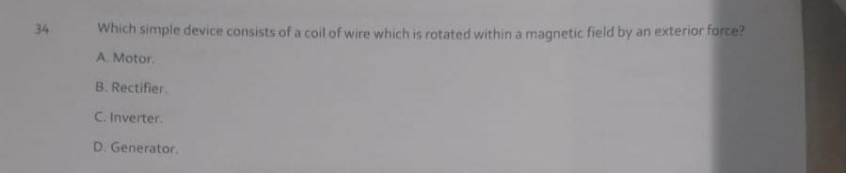

Question 35
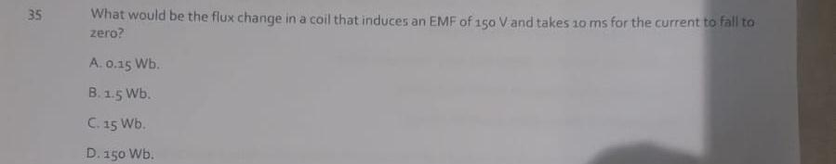

Question 36
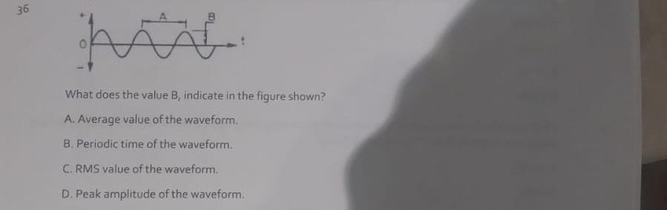

Question 37
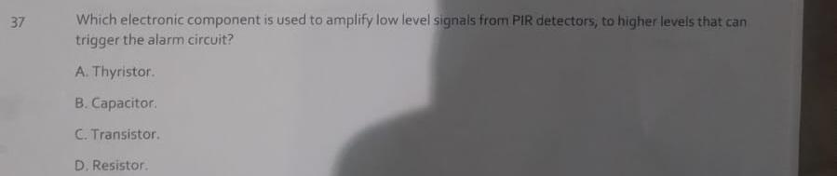

Question 38
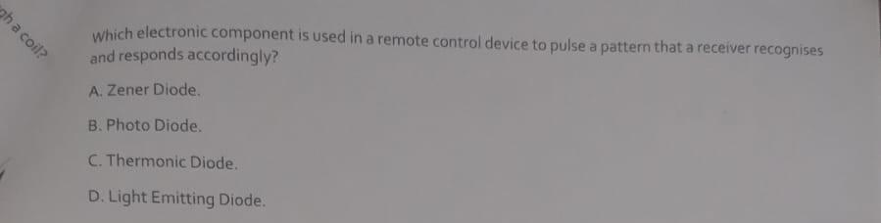

Question 39
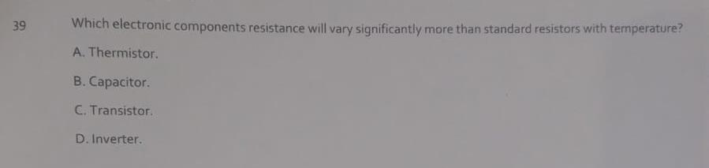

Question 40
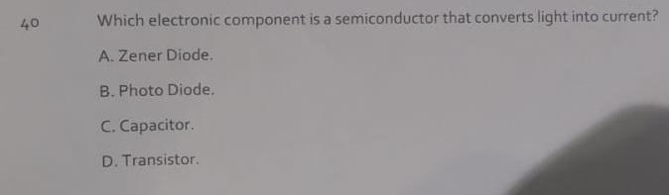

Classroom theory

Mass never changes and stays the same.
Weight changes due to the impact of gravity. A person would have a different weight on earth compared to outer space.

